**Student: Roy Houber + Menashe Mataev : 322274259_207764374**

**1.1**

**1.2**

**Use case name :** עדכון מלאי והתראה על חוסרים

**Textual Description :** המשתמש מעדכן את המלאי על ידי סימון מוצרים כפגומים, או על ידי מכירת פריטים, והמערכת מתריאה על חוסרים בהתאם.

**List of Actors :** המשתמש.

**Preconditions:** המוצרים אותם המשתמש מנסה לעדכן קיימים במערכת. **Postconditions:** המלאי עודכן בהתאם לinput, והמערכת הוציאה התראה במידה ונדרש. **Main success scenario:**

1. המשתמש מעדכן את המלאי על ידי סימון מוצרים כפגומים או על ידי מכירת פריטים.
2. המערכת מעדכנת את מסד הנתונים בהתאם.
   1. לאחר העדכון, המערכת בודקת את מצב המלאי של המוצרים שהוזמנו – במידה והכמות יורדת מקו המינימום, המערכת מוציאה התראה.

**Alternatives/Extensions: אין**

Sell Item

Enter product ID

Failure: product ID doesn’t exist or insufficient product quantity.

Success: The item was sold successfully and if the product reached below minimum quantity, automatic order sent to supllier

Back to main menu

**Use case name :** הוספת ספק חדש

**Textual Description :** המשתמש מוסיף ספק חדש למערכת.

**List of Actors :** המשתמש.

**Preconditions:** הספק אינו קיים כבר במערכת. **Postconditions:** הספק נכנס למערכת ונשמר במסד נתונים. **Main success scenario:**

1. המשתמש מוסיף ספק למערכת.
2. המשתמש מתבקשת למלא עליו את הפרטים הבאים – שם, הנחה (במידה וקיימת).

**Alternatives/Extensions:**

1. במידה והספק כבר קיים במערכת, המערכת תוציא שגיאה והספק לא ישמר.

Add Supplier

Enter supplier details

Success: The supplier added successfully

Failure: some of the details are incorrect.

Back to main menu

**2.1**

**2.2**

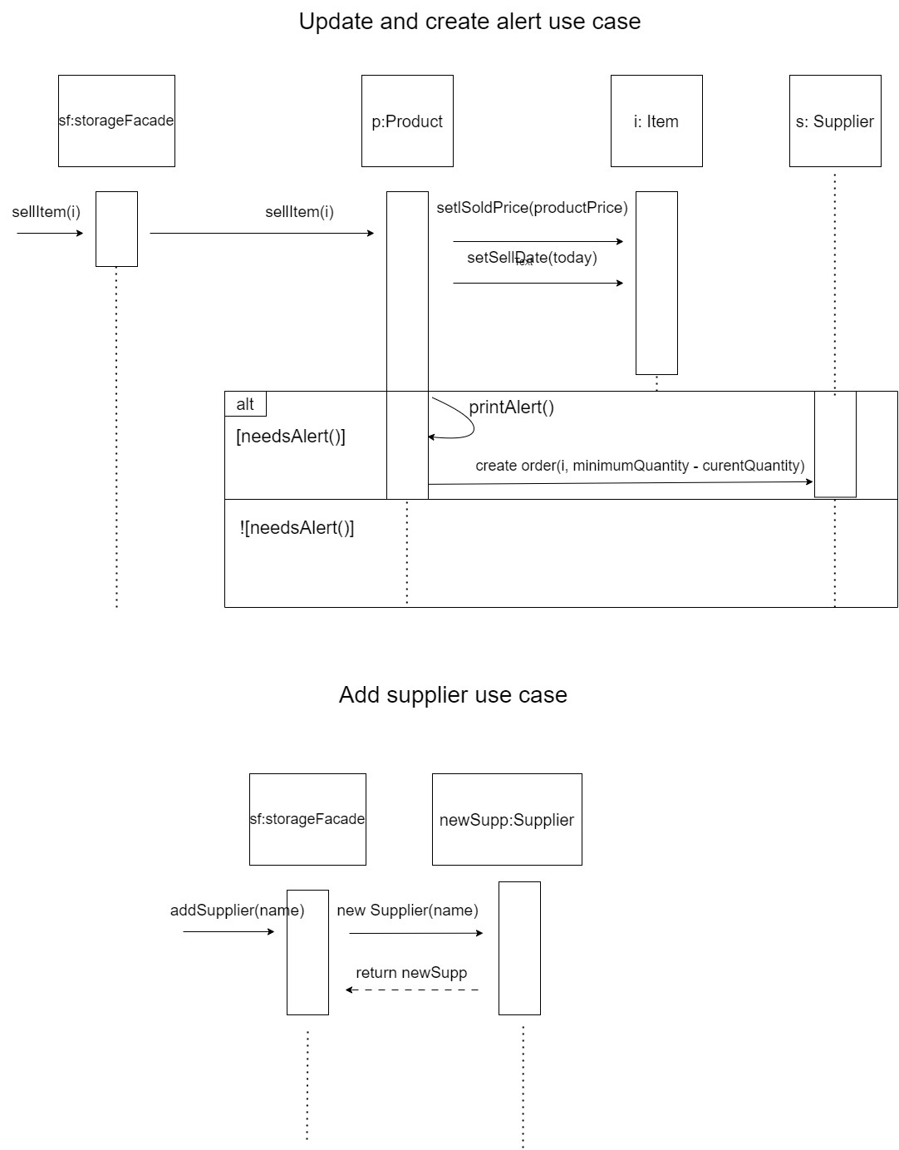

**3.1 - UML.pdf in the zip file**

**3.2**

**Requirements – Storage Module**

*The requirements are ordered by priority*

*Colored lines symbols adds/changes from assignment1 to assignment2*

*Colored lines symbols adds from our perspectives to system requirements*

|  |  |  |  |  |  |  |  |
| --- | --- | --- | --- | --- | --- | --- | --- |
| ID | Module | Func/Non-Fun | Description | Priority | Risk | Status | Executable\  Reason |
| 1 | Storage | NF | The system will be built with the same technologies of the other module that is simultaneously being built by the second team. | MH | Low | - | No. Will be available after all modules are built. |
| 2 | Storage | F | For every product, the system will allow the user to add and update the following details: id, where it is placed, who supplied it, quantity left (split to store and storage), category, subcategory), minimum required. | MH | Low | Done | Yes |
| 3 | Storage | F | The system will monitor if products quantity runs below the minimum required and automatically order new sufficient stock. | MH | High | In progress | Yes |
| 5 | Storage | F | The system will order new product stock automatically every predefined period .The automatic period order should be sent to the supplier at least one day before. | MH | High | In progress | Yes |
| 6 | Suppliers | F | For every new product stock order the system will calculate the best fitted supplier to order from, calculated by the lower supplier price. | MH | High | In progress | Yes |
| 7 | Storage | F | The system will allow the users to create reports based on categories, subcategories, sizes or bad items (outdated/damaged) | MH | High | Done | Yes |
| 8 | Storage | F | The system will allow the user to monitor the quantity of products available. | MH | High | Done | Yes |
| 9 | Storage | F | The system will monitor and record the price of the products include the supplier price and the sell price. | MH | Low | Done | Yes |
| 10 | Stroage | F | The system will allow the user to put a discount percentage on a product for a limited amount of time. | MH | High | Done | Yes |
| 11 | Stroage | F | The system will have the option to sell an item. | MH | Low | Done | Yes |
| 12 | Stroage | F | The system will have the option to change product state (undamaged to damaged). | MH | Low | Done | Yes |
| 13 | Stroage | F | The system will have the ability of adding/deleting new categories, sub-categories, products and items. | MH | Low | Done | Yes |
| 14 | Storage | F | The system will have the ability to filter products by categories and subcategories. | MH | Low | Done | Yes |
| 15 | Storage | F | The system will allow the user to filter products by size | MH | Low | Done | Yes |
| 16 | Stroage | F | The system will have the ability to track damaged or date expired products | MH | Low | Done | Yes |
| 17 | Stroage | F | The system will allow the creation of multiple storages. In order to be flexible for future company growth. | NTH | Low | Done | Yes |
| 18 | Stroage | F | After every published report on damaged items, the system will drop those items from the storage. | NTH | Low | Done | Yes |

**Questions for the client:**

|  |  |  |  |
| --- | --- | --- | --- |
| ID | Topic | Issue | Notes |
| 1 | Minimum Quantity | How is the minimum quantity for each item is being decided - the storage manager doing it manually or is it a decided automatically by some formula? |  |
| 2 | Alert system | How does alerts show to the user? |  |
| 3 | Reports | How should reports look like? Diagrams, Tables … | Client answer: It is up to us, there is not concrete way to do it. |
| 4 | Period order | How do we defined the period? should we order every month? Or every year? … |  |
| 5 | New Product Stock | How should we calculate the sufficient new stock we need to order? Should we check average period sells? or by constant? … |  |

**Explanations for changing requirements:**

**Requirement 2 : Added new minimum required field for each products to measure if product runs below some quantity.**

**Requirement 3 : No system alerts anymore. The system will automatically order new product stock who's runs below the minimum required.**

**Requirement 4 : New Requirement.**

**Requirement 5 : New Requirement.**

**ne**